**EXAMINATION MANAGEMENT SYSTEM**

End Term Report

***by***

**K.RISHIK REDDY B.CHAKRADHAR RAO K.SURENDRA PAUL**

Section: - K19TP SECTION:-K19TP Section:-K19TP

Roll Number: - 17 Roll Number:-55 Roll Number:-35



Department of Intelligent Systems

School of Computer Science Engineering

Lovely Professional University, Jalandhar

2019-20

**Student Declaration**

This is to declare that this report has been written by me/us. No part of the report is copied from other sources. All information included from other sources have been duly acknowledged. I/We aver that if any part of the report is found to be copied, I/we are shall take full responsibility for it.

K.RISHIK REDDY

Roll Number: - 17

B.CHAKRADHAR RAO

Roll Number:-55

K.SURENDRA PAUL

Roll Number:-35

Place: - Lovely Professional University, Phagwara, Punjab

Date: - 9/4/2020

TABLE OF CONTENTS

TITLE PAGE NO.

1. **Background and objectives of project assigned…………. 5**

**1.1** Background……………………………………………… 5

**1.2** Outcomes………………………………………………. 5

**1.3** Main Moto………………………………………………… 5

**1.4** Objectives…………………………………………… 6

2.**Description…………………………………………………… 6**

**2.1** Header and Navigation Bar………………………………. 6

**2.2** Content…………………………………………………… 7

**2.3**Feedback………………………………………… 8

BONAFIDE CERTIFICATE

Certified that this project report “EXAMINATION MANAGEMENT SYSTEM” is the bonafide work of “K.RISHIK REDDY , B.CHAKRADHAR RAO ,

K.SURENDRA PAUL” who carried out the project work under my supervision.

<<Signature of the Supervisor>>

<<Name of supervisor>>

<<Academic Designation>>

<<ID of Supervisor>>

<<Department of Supervisor>>

**Introduction**

* 1. **Background**

The website “EXAMINATION MANAGEMENT SYSTEM” is especially designed website where students can know about there seating plan for there exams and also the student can know there result .In our website whatever student facing problem they can contact us and they can have there queries.And they can give there valuable feedback to us so that we can our your ideas to develop our website.This website is useful for students.

* 1. **Outcomes**

Our outcome when we are designing our website we understood a lot of topics about how we can design a webpage and we have also made and added CSS and got a command on it.CSS used to design the webpage and add stylesheet to it by this way we have add css to our html pages and we have linked those pages to our main page.By this we have understood mostly the websites and webpages and stylesheet for that webpages is done by these css.

* 1. **Main Moto**

Our main moto of designing these websites and webpages is to provide a good and ease of accessing our website to know about there seating plans,results,exams which gives a complete detailed informations about your “Examination system”.

* 1. **Objectives**

The main objective of our website is to clear all the queries of students about there examination system and those all in this the student gets there detailed information in this website this website is use full for students.

**Description**

**2.1** Header and Navigation Bar:-

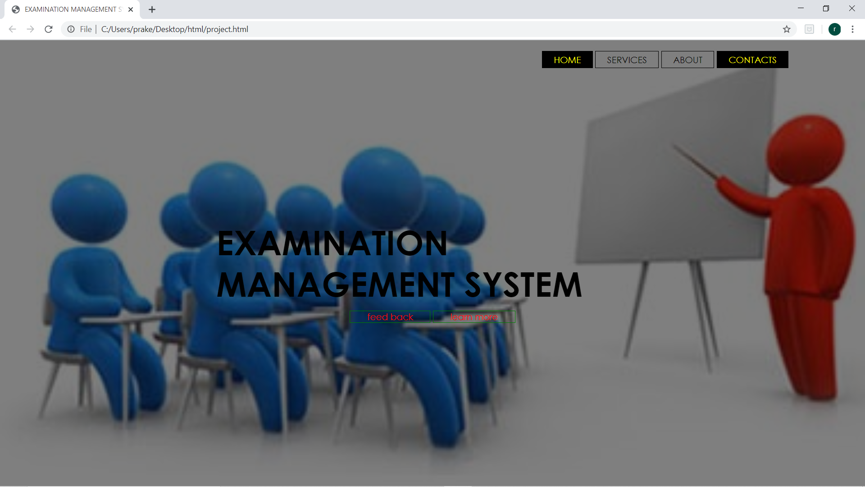

When you open our website you can see the “Navigation bar” where it is shown on the right and topof the main webpage .It is having (the webpage is having a background image on main page.)a background .In this web page where you can see the buttons on navigation bar which is having a color shown as yellow in colour and there are total four button they are:-HOME,SERVICE,ABOUT,CONTACTS.In this buttons the home button and contacts button are active every time.

When you curse your mouse on the buttons you can get the mouse converts into hand symbol and the button activates and shows a background colour black and the button colour as yellow.When you click on these navigation button these button links to other webpages.

In this web page you can find a heading known as

“EXAMINATION MANAGEMENT SYSTEM” which is in bold and black and it is aligned in center and middle of the webpage.

**2.2 Content**

In our webpage the main content is in the Navigation buttons

HOME:-

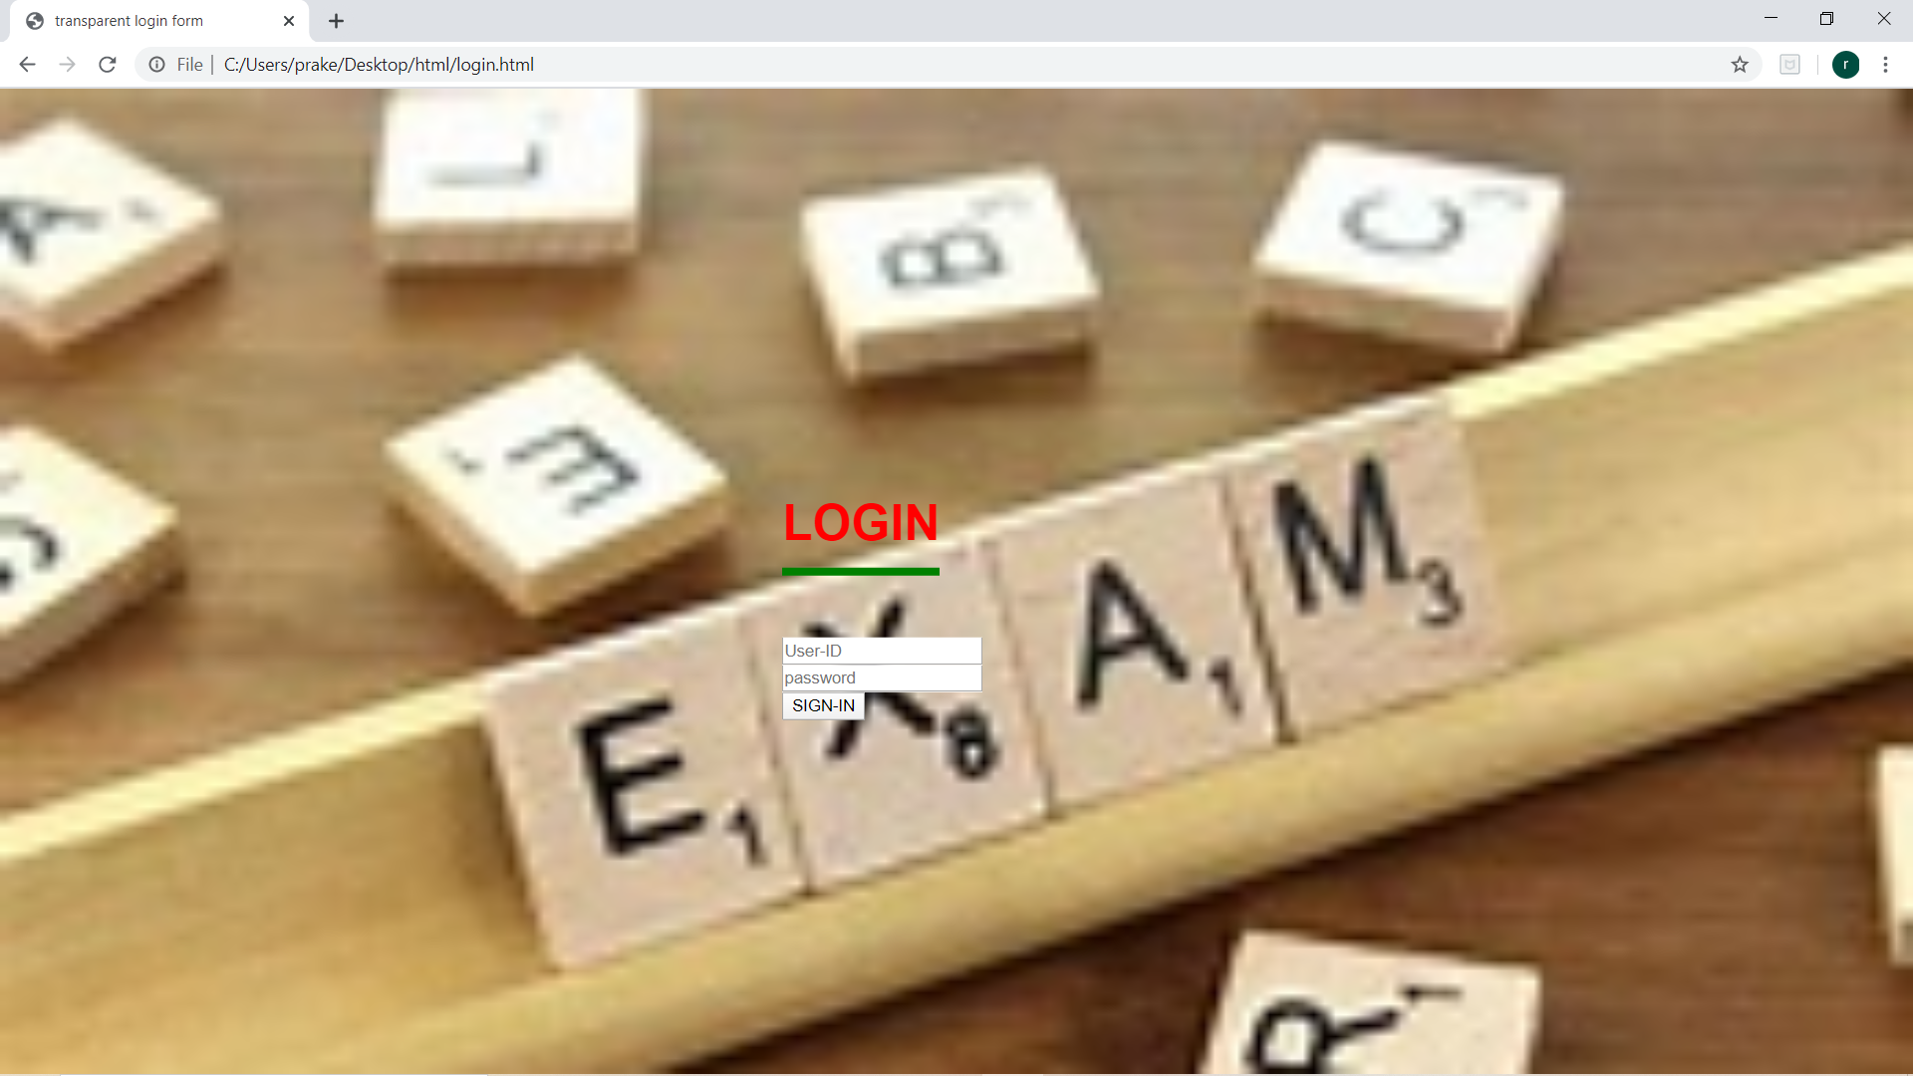

When you click on home button where you are linked to the other webpage.

In the new page where you can find a background image related to EXAM and you can find a heading known as “LOGIN” which is in red colour and also underlined in green colour.In the below of login you can see a box where it tends as “USER ID” where the student should enter his/her id and below of it you can see another box it tends as “PASSWORD” where the student should enter his/her password.

Then click on “SIGN IN” button to know the details.

SERVICE:-

When you click on the navigation button “service” it links to another page which is service page of the web page.

CONTACTS:-

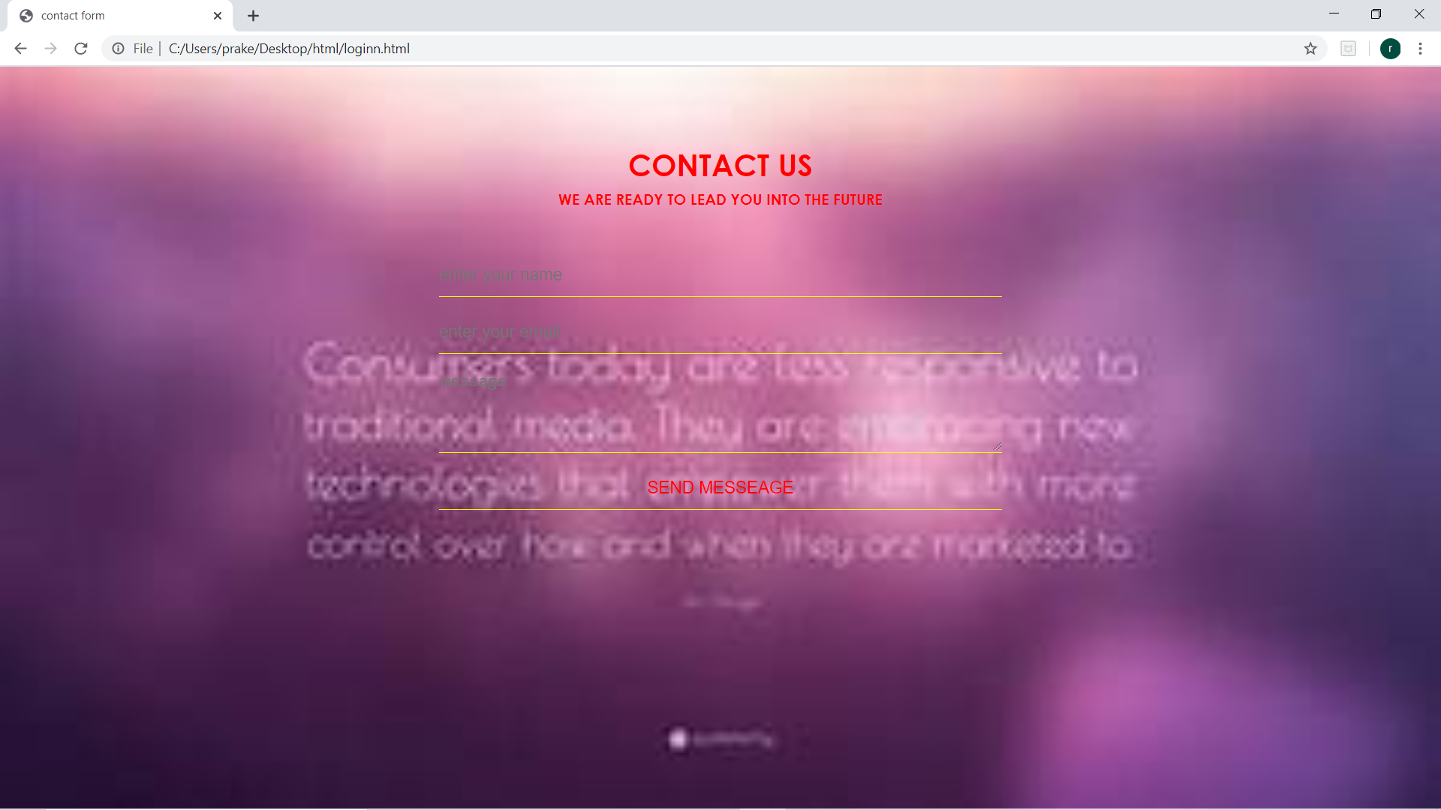

CONTACTS is a navigation button which is active in webpage it is another web page when we click on it it links to another page where we can see an heading in bold “CONTACT US” and another heading below of it or a caption “we are ready to lead you into the future”.The both the headings are red in colour.

After that there the student should enter his/her details(enter your name,enter your email,message)after that the student should click on the send message and they will be contacted by us for there queries.

**2.3 FEEDBACK**

In our main webpage we feedback button which is enclosed in a box in which is red in colour and the feedback button is green in colour in this the students can drop there valuable feedback in our website.